Can we restart a dead thread? No

**Inter thread Communication :** It is important when we develop an application where two or more threads exchange some data and information. There are three different methods of class Objet ( **wait(), notify, notifyAll()** ) of Object class which makes it possible.

**Wait() :** On calling wait method the current thread must releases the ownership of this **monitor**(the object of that class which is holding the lock) and waits until another thread notifies the waiting thread on this object monitor to wake up. this can be done either through call by **notify()** method or by **notifyAll()** method.

There are three different wait method with different parameter:

1. Wait(long) 2. Wait(long , int) and 3. Wait()

**Note** : All three methods **wait() , notify() or notifyAll()** method must be called within the synchronized method/block otherwise it will be throw **IllegalMonitorStateException**

**notify() :** This method wakes up a single thread that is waiting on its object monitor. If any thread is waiting on this object one of chosen can be awaken. the choice is arbitrary and occurs at discussion of implementation. the thread will be awakened but this awakened thread cannot start execution until the current thread releases the lock on this object. This method can be called only by the thread that is owner of this object monitor . A thread becomes owner of the thread monitor as three ways :

**notifyAll()** : this method basically wakes up all the thread that are waiting on the object’s monitor. This method can only be called by thread that is owner of object’s monitor

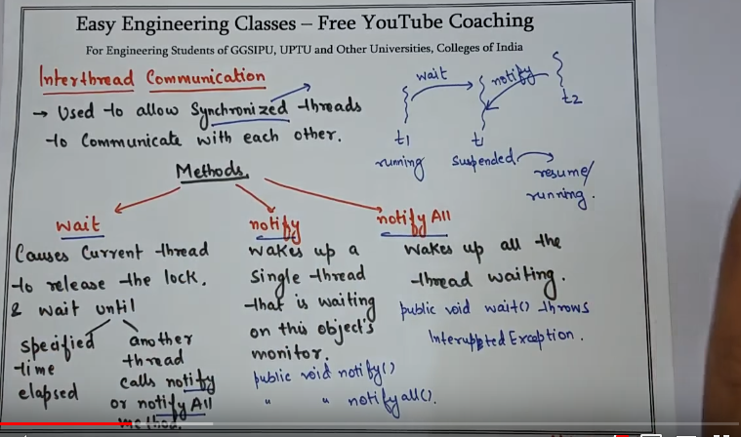

**Producer Consumer problem** :

